**Jenkins File:**

Jenkins Pipeline is a way of Jenkins to implement CI/CD i.e continuous integration and continuous deployment. To implement Jenkins pipeline we use Jenkins file.

Jenkinsfile is basically a pipeline as code.

* First of all start your Jenkins.
* Then install pipeline plugin.
* Create a new job.
* Create or get Jenkins file in pipeline section.

Jenkins file can be written using two types of syntax- Declarative and scripted , both are written with groovy but have a diff structure.

We can write the declarative code in the Jenkins job itself or else we can choose jenkinsfile present inside source code management.

The code inside jenkinsfile can be written as below:

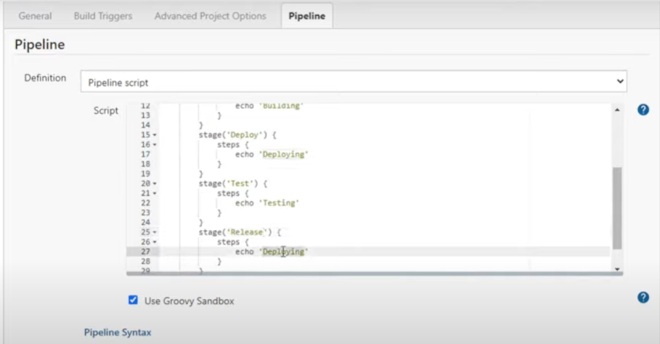

Once the job created for pipeline is created then apply and save it.

Then click on build now to run the job. The various stages that are mentioned will run and we can see a pipeline view of all the stages on the cosole itself as given below:

